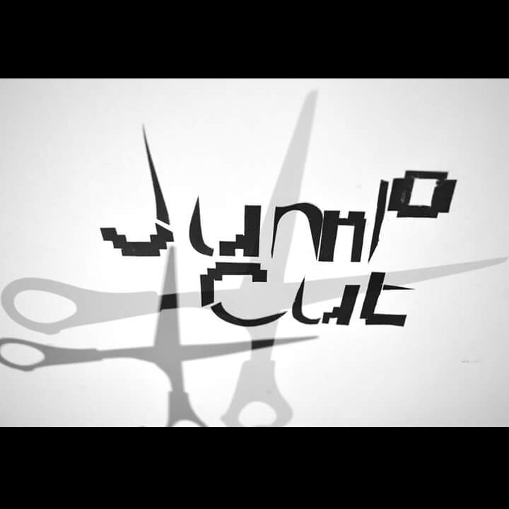 | Costume Plot Form
 | Production: Username
 | Designer Documentation Completed By (Set, Props and Costume): Rosalie Chase
Scene |  | Actor | Costume Items | Notes
1  Imperfections & Insecurities |  | Harriet Haynes | X | Actor is not on stage throughout scene.
 |  | Chloe-Ann Gudge | X | Actor is not on stage throughout scene.
 |  | Rosalie Chase | X | Actor is not on stage throughout scene.
2  The manipulation of the Body |  | Harriet Haynes | High waist, low leg shape-wear pants (Black)  Spaghetti strap fitted top (Black) | Actors costume is not visible on stage as actor is positioned (UR) behind the projector screen.
 |  | Chloe-Ann Gudge | High waist, low leg shape-wear pants (Black)  Spaghetti strap fitted top (Black) | Actors costume is not visible on stage as actor is positioned (UC) behind the projector screen.
 |  | Rosalie Chase | High waist, low leg shape-wear pants (Black)  Spaghetti strap fitted top (Black) | Actors costume is not visible on stage as actor is positioned (UL) behind the projector screen.
3  Sculpting the Face |  | Harriet Haynes | High waist, low leg shape-wear pants (Black)  Spaghetti strap fitted top (Black)  Dressing Gown (Pink)  Bare feet | Actor puts dressing gown on top of clothing behind the projector screen, actor is still positioned UR  Actor then moves to DR
 |  | Chloe-Ann Gudge | High waist, low leg shape-wear pants (Black)  Spaghetti strap fitted top (Black)  Dressing Gown (Red)  Bare feet | Actor puts dressing gown on top of clothing behind the projector screen, actor is still positioned UC  Actor then moves to DC
 |  | Rosalie Chase | High waist, low leg shape-wear pants (Black)  Spaghetti strap fitted top (Black)  Dressing gown (Burgundy) | Actor puts dressing gown on top of clothing behind the projector screen, actor is still positioned UL  Actor then moves to DL
4  Sculpting the Face & Short Movement Sequence |  | Harriet Haynes | High waist, low leg shape-wear pants (Black)  Spaghetti strap fitted top (Black)  Dressing Gown (Pink) | Actors moves from DR to UR
 |  | Chloe-Ann Gudge | High waist, low leg shape-wear pants (Black)  Spaghetti strap fitted top (Black)  Dressing Gown (Red) | Actors moves from DC to UC
 |  | Rosalie Chase | High waist, low leg shape-wear pants (Black)  Spaghetti strap fitted top (Black)  Dressing Gown (Burgundy) | Actors moves from DL to UL
5  Selection of Outfit |  | Harriet Haynes | Black opaque tights  White lace straight dress (No sleeves/Above knee length) | Actor must complete all outfit changes
Black Opaque tights
Purple Pencil skirt
Loose fitted wing shaped high neck blouse (Black)
Black opaque tights
White short sleeved tunic top
Dusty pink/beige A-line skirt

Black opaque tights
Leopard Print tunic top
Burgundy short skirt

Black opaque tights
Grey and black checked fitted skirt
Burgundy loose fitted cropped top with short sleeves
Black opaque tights
Burgundy and black tie dye, knee-length fitted dress

Black opaque tights
Blue fitted pencil skirt
Black swoop neck fitted vest top
Black opaque tights
Purple peplum styled fitted dress (U Neckline)
 |  | Chloe-Ann Gudge | Black opaque tights  Aztec two patterned A-line dress with peter pan collar | Actor must complete all outfit changes
Black opaque tights
Leopard print dress with black peter pan collar

Black opaque tights
White short sleeved tunic top
Dusty beige/pink A-line skirt

Black opaque tights
Pink spaghetti strap kami top
Black fitted pencil skirt

Black opaque tights
Red long sleeve blouse (V Neck)
Black fitted pencil skirt

Black opaque tights
Black spaghetti strap kami top
Black fitted pencil skirt with cream vertical panel (giving the illusion of an elongated and slim body)

Black Opaque tights
Black knee length dress with cream vertical panel (giving illusion of a slimmer body/ peplum style dress)
Black opaque tights
White/Black fitted dress with off-shoulder neck line and detailed black lace waist

 |  | Rosalie Chase | Black opaque tights  Cream/Red and brown patterned oversized blouse  Loose fitted pencil skirt | Actor must complete all outfit changes
Black opaque tights
Blue/Cream patterned wing crop top
Black A-line skirt

Black opaque tights
Loose fitted winged shape high neck blouse (Floral/Black)
Black A-line skirt
Black opaque tights
Black/Grey fitted dress with small leather outlined pockets and neck
Black opaque tights
Black turtle neck long sleeved dress

Black opaque tights
Black and Grey rose print blouse
Blue denim A-line skirt
Black opaque tights
Black dress with cutout shoulders
Burgundy A-line skirt

Black opaque tights
Black off-shoulder fitted top
Burgundy A-line skirt

6  Contorting the Body |  | Harriet Haynes | Black opaque tights  Black opaque tights  Purple fitted Dress with u neckline  Black platform ankle strap heels | Actor remains DR
 |  | Chloe-Ann Gudge | Black opaque tights  White/Black fitted dress with off-shoulder neck line and detailed black lace waist  Black wedged heels | Actor remains DC
 |  | Rosalie Chase | Black opaque tights  Black off-shoulder fitted top  A-line burgundy skirt  Black wedged heels | Actor remains DL
7  Uploading the ‘Perfect’ Selfie |  | Harriet Haynes | Black opaque tights  Blue fitted pencil skirt  Black swoop neck fitted vest top | Actor can choose when to change costume. However, order must stay the same.
Black opaque tights
Burgundy and black tie dye, knee-length fitted dress
Black opaque tights
Grey and black checked fitted skirt
Burgundy loose fitted cropped top with short sleeves
Black opaque tights
Leopard Print tunic top
Burgundy short skirt
Black opaque tights
White short sleeved tunic top
Dusty pink/beige A-line skirt

Black Opaque tights
Purple Pencil skirt
Loose fitted wing shaped high neck blouse (Black)
Black opaque tights
White lace straight dress (No sleeves/Above knee length)
 |  | Chloe-Ann Gudge | Black Opaque tights  Black knee length dress with cream vertical panel (giving illusion of a slimmer body/ peplum style dress) | Actor can choose when to change costume. However, order must stay the same.
Black opaque tights
Black spaghetti strap kami top
Black fitted pencil skirt with cream vertical panel (giving the illusion of an elongated and slim body)
Black opaque tights
Red long sleeve blouse (V Neck)
Black fitted pencil skirt
Black opaque tights
Pink spaghetti strap kami top
Black fitted pencil skirt
Black opaque tights
White short sleeved tunic top
Dusty beige/pink A-line skirt
Black opaque tights
Leopard print dress with black peter pan collar
Black opaque tights
Aztec two patterned A-line dress with peter pan collar
 |  | Rosalie Chase | Black opaque tights  Black dress with cutout shoulders  Burgundy A-line skirt | Actor can choose when to change costume. However, order must stay the same.
Black opaque tights
Black and Grey rose print blouse
Blue denim A-line skirt
Black opaque tights
Black turtle neck long sleeved dress
Black opaque tights
Black/Grey fitted dress with small leather outlined pockets and neck
Black opaque tights
Loose fitted winged shape high neck blouse (Floral/Black)
Black A-line skirt
Black opaque tights
Blue/Cream patterned wing crop top
Black A-line skirt
Black opaque tights
Cream/Red and brown patterned oversized blouse
Loose fitted pencil skirt

