Choreography Influences

An integral part of our work is establishing the narrative and theme through movement and dance. The choreographic segments devised in Username are to represent how body image is becoming an issue and how social media and technology is contributing to this obsession with unattainable beauty. As our piece is primarily physical, I understood how the choreographic choices would need to be delivered effectively in order to provoke an emotional response from an audience.

I believe that movement should stem from an improvisational approach.

The movements in Username are to be clear and strong to reveal how we are increasingly becoming brainwashed to these fascinations, obsessive trends and to something that is unattainable. The increasingly ridged movement (similar to a puppet) will compliment the harsh backlight that will be projected onto the projector screens. This will give our individual shadows a sharper and more a definable (to an audience) silhouette whilst moving. The movement will also be complimented by the sound of a metronome; due to the repetition of the sound this will give the audience a sense of a loss of time and demonstrate how we as individuals spend so much time constantly trying to achieve this image. (The movement will be repeated three times to support this idea).

An Influential Artist:

I began my choreographic journey by researching into and taking notes from several companies/artists, contemporary dance artists and online tutorial videos.

Anne Teresa De Keersmaeker – Particularly inspired by this artist. Her work experiments with theatre, text and film. Many of her works have been adapted for the screen.

“I have a love-hate relationship with [unison and repetition]. In some piece I use them a lot; in others I don’t. What I like about them is the way you can make one thing more empathic, but also how you can point to small distinctions with different bodies execute the same movement” (Roy, 2009)

She pushes repetition to the limit, this is something I will explore and demonstrate when making choreographic decisions for Username. The repetition will be representative of individuals trying to achieve perfection and constantly failing.

Influential Works:

Fase – Anne Teresa De Keersmaeker & Michele Anne de Mey
- Interesting use of front lighting to create a double shadowed effect
- Influenced the idea of creating shadows/silhouettes on projector screens
- The on-going music inspired the idea of the metronome sound

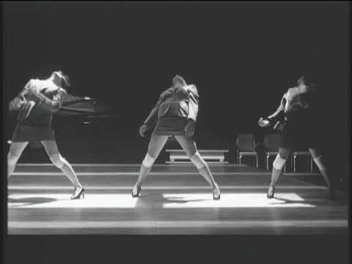
https://www.youtube.com/watch?v=RTke1tQztpQ

Rosas Danst Rosas – Anne Teresa De Keersmaeker
The use of repetitions & unison
The effective use of the breath – to demonstrate exhaustion

https://www.youtube.com/watch?v=oQCTbCcSxis

Achterland – Anne Teresa De Keersmaeker (Picture right)
Inspired by the use of shoes – the risk of falling over/idea of destruction
The light and movement amalgamating harmoniously – each individual will perform in a box of harsh light to show how the individual can become consumed by technology and the media’s depiction of ideal.
Youtube (2010)
https://www.youtube.com/watch?v=tVd7RugO_Xk

Distorted Images – RhetOracle Dance Company

“This dance is a journey in finding a positive perception of one’s self and the way that others, who cannot, deal with it” (YouTube, 2011).

- The idea of having props – Tape measurers/Mannequins

https://www.youtube.com/watch?v=Zzyi1tgTLpg

Perfect Beauty – How To Look Skinny Slimmer In Photos

This video is an online tutorial giving individuals demonstrations and instructions on how to look skinny/slimmer in their online photos.

- Inspired many choreographic segments throughout the piece including the ‘contorting the body’ and ‘sculpting the face’ scenes.

https://www.youtube.com/watch?v=LGdetVH8144

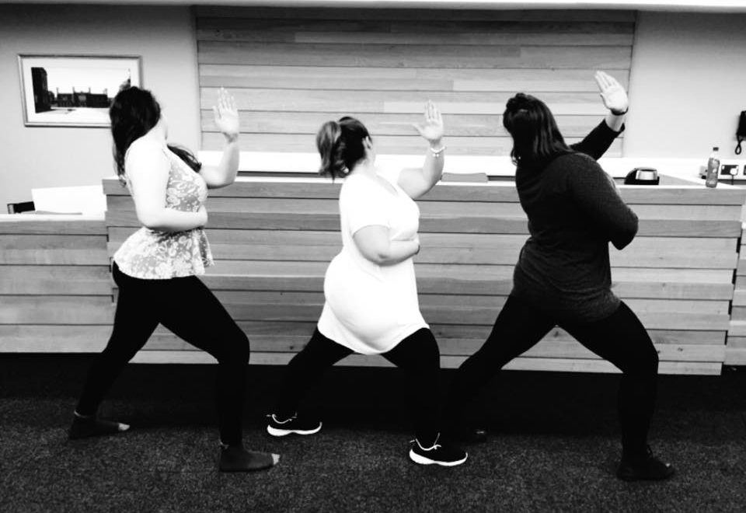
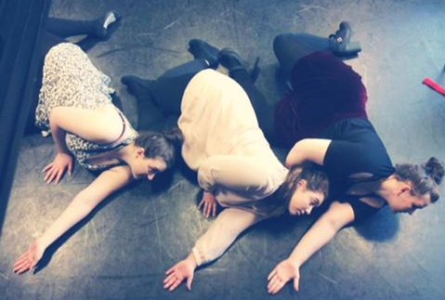

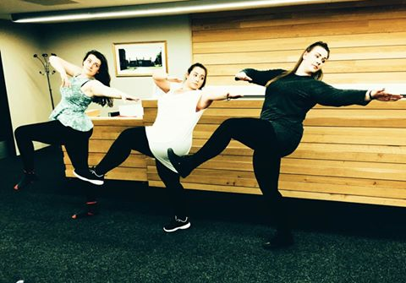

Chase, R. (2015) Username. [Choreography Images] Lincoln.

Works Cited:

Chase, R. (2015) Username. [Choreography Images] Lincoln.

Perfect Beauty. (2014) How To Look Skinny Slimmer in Photos. [online video] Available from: https://www.youtube.com/watch?v=LGdetVH8144 [Accessed 25 April 2015].

Roy, S. (2009) Step-by-step guide to dance: Anne Teresa de Keersmaeker and Rosas. [online] Available from: http://www.theguardian.com/stage/2009/sep/08/dance-anne-teresa-de-keersmaeker-rosas [Accessed 5 March 2015].

YouTube. (2010) Achterland, Anne Teresa De Keersmaeker 3 de 7. [online video] Available from: https://www.youtube.com/watch?v=tVd7RugO_Xk [Accessed 20 April 2015].

YouTube. (2011) Distorted Images – RhetOracle Dance Company – Choreographed by Bryana Verner. [online video] Available from: https://www.youtube.com/watch?v=Zzyi1tgTLpg [Accessed 5 March 2015].

YouTube. (2009) Fase - Anne Teresa De Keersmaeker & Michele Anne De May. [online video] Available from: https://www.youtube.com/watch?v=RTke1tQztpQ [Accessed 23 April 2015].

YouTube. (2008) Rosas – Rosas Danst Rosas. [online video] Available from: https://www.youtube.com/watch?v=oQCTbCcSxis [Accessed 20 April 2015].

