3D Scaled Down Model Set Design

Theatre Company: JumpCut Theatre
Production: Username
Designer Documentation Completed By (Set, Costume and Props): Rosalie Chase

Scale:
1000mm = 50mm
1m = 5cm
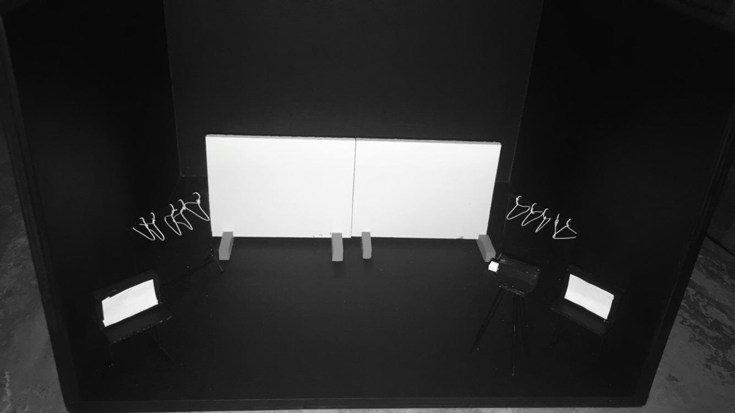
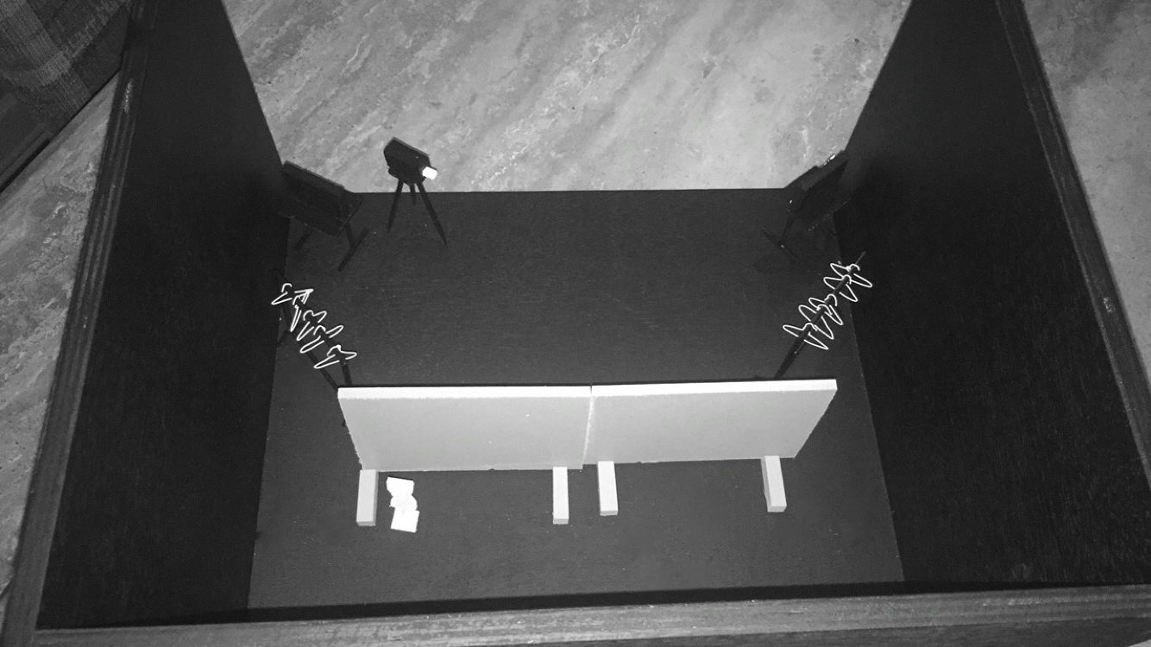

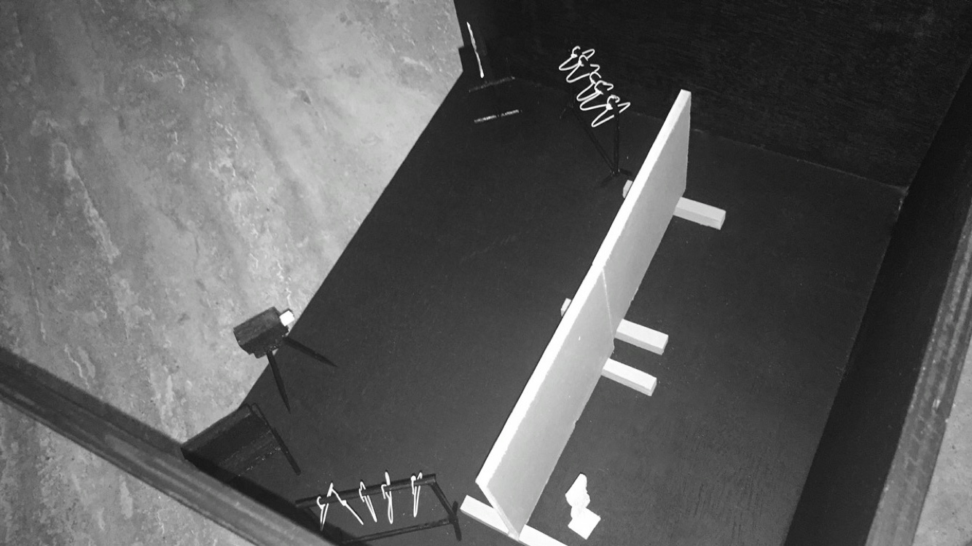

Scaled down Measurements

Stage: 400mm (W)
350mm (D)
250mm (H)

Projector Screens: 130mm (W)
100mm (H)

Projector Screen Legs: 70mm (L)

TV Monitors: 40mm (W)
25mm (H)

Dressing Rails: 75mm (W)
65mm (H)
15mm (Leg Downward)
5mm (Leg Outward – Not shown in model)

Mannequin: 15mm (Bust)
10mm (Waist)
15mm (Hips)
40mm (Nape to Hips)

Tripod and
Hand-held Camera: 75mm (L)
17.5mm (W) – Estimate of Camera
7.5mm (H + D) – Estimate of Camera

Hangers are not scaled models.

